

Part 1: Multi-threaded Web Server:

Server Side:
Server has a Server Socket , Several Clients Sockets assigned when ever a Connection is established between Client and the Server , Server Port and a Thread is created for each connection to serve the client request
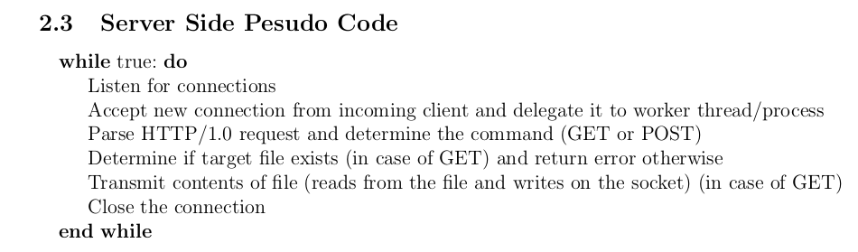
Server Runs for ever and Listen for connections and when it accepts new connection the server delegate it to worker thread
we choose to implement a multi-threaded approach as it is very expensive to fork a new process to handle each client due to the fact that the Operating System must duplicate the entire state of the parent process including memory , stack, file/socket descriptors. But Threads decrease this cost by allowing multitasking within the same process as it simply shares the same address space with the parent.

Then each Thread assign new Client socket from each request as the established TCP connection Socket between The server and that Client
Command to run the server:
./HTTPServer port_number
server should accept incoming connection requests. It should then parse the command and look for the GET request and pick out the name of the requested file. If the request is POST then it sends OK message and wait for the uploaded file from the client. server should first print out the received command then respond with the line
reply message:
HTTP/1.0 200 OK\r\n
then in case of GET command only:
{data, data, ...., data}

Part 2: HTTP Web Client:
each Client has Server IP , Server Port and Multiple Commands as File
each Client creates Client Socket then establish a Connection to the Server

client must read and parse a series of commands from input file.
The commands syntax should be as follows:
GET file-name host-name (port-number)
POST file-name host-name (port-number)
Note that the port-number is optional. If it is not specified, use the default HTTP port
number, 80

first we Create Command Struct that is consisted of
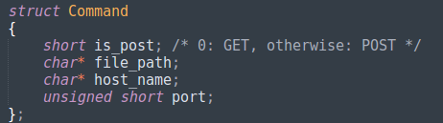
and at the beginning of the Client we parse the command in this struct

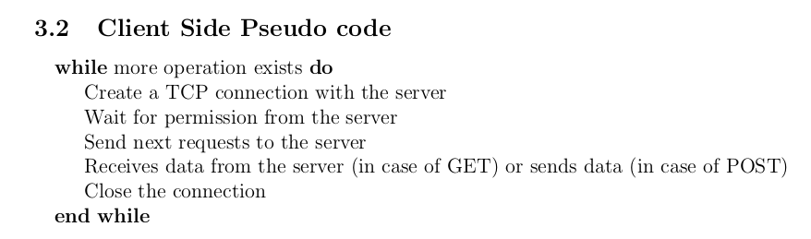
Command to run the Client:
./HTTPClient server_ip port_number Commands_File

The major functions :

